Lab 5: Adversarial Search
Minimax & Alpha-Beta Pruning
Artificial Intelligence Lab (CAI601400) · Week 5 · CLO2 (C3: Apply)

1. Objective
The objective of this lab is to understand and implement the Minimax algorithm and Alpha-Beta Pruning in Python. Both algorithms are used in two-player games to select the best move. We will compare their performance by counting the number of leaf nodes evaluated and observing how branch ordering affects pruning.

2. Introduction
Adversarial search is used in Artificial Intelligence when two players compete against each other. Examples include chess, tic-tac-toe, and checkers.
In these games, one player tries to maximize the score, while the other tries to minimize it.
- MAX player: Tries to get the highest possible score.
- MIN player: Tries to get the lowest possible score for MAX.
- Game tree: Represents the possible moves of both players.
- Terminal node: A leaf node that contains a final score.
- Minimax: Finds the best decision by evaluating the tree from the leaves to the root.
- Alpha-Beta Pruning: Improves Minimax by skipping branches that cannot affect the final decision.

3. Real-World Problem
A game-playing AI must choose the best move while assuming that its opponent will also play intelligently. Evaluating every possible move can require a lot of time. Alpha-Beta Pruning helps the AI avoid unnecessary evaluations without changing the optimal Minimax result.

4. Learning Outcomes
After completing this lab, students will be able to:
- Represent MAX and MIN decisions in a game tree.
- Calculate Minimax values from leaf nodes to the root.
- Implement Alpha-Beta Pruning using alpha and beta bounds.
- Count and compare evaluated leaf nodes.
- Explain how branch ordering affects pruning efficiency.
- Test both algorithms and interpret their results.

5. Theory

5.1 Minimax Algorithm
Minimax is a decision-making algorithm used in two-player, zero-sum games.
It assumes that both players make the best possible decisions. MAX selects the largest value, while MIN selects the smallest value.
The algorithm works as follows:
- Start from the leaf nodes containing scores.
- At each MIN node, choose the minimum child value.
- At each MAX node, choose the maximum child value.
- Continue until the root node is reached.
- The root value represents the best achievable outcome for MAX, assuming optimal play.

5.2 Alpha-Beta Pruning
Alpha-Beta Pruning is an optimization of the Minimax algorithm. It skips branches that cannot change the final decision.
- Alpha (α): The best value MAX can guarantee so far.
- Beta (β): The best value MIN can guarantee so far.
- Pruning condition: Stop exploring the remaining children when α ≥ β.
Alpha-Beta Pruning returns the same Minimax value for the same game tree, but it may evaluate fewer leaves.

6. Practical Implementation
We will use a fixed game tree with eight terminal scores: [3, 5, 6, 9, 1, 2, 0, -1]
The tree has three levels of decisions below the root. MAX plays at the root, MIN plays at the next level, and MAX plays again before reaching the terminal scores.

6.1 Game Tree
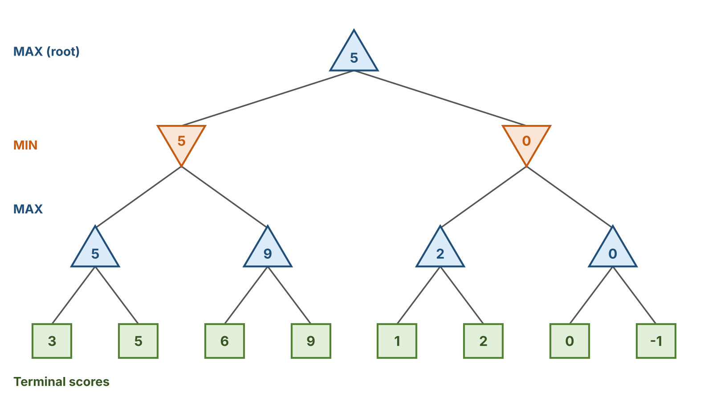
Figure 1: Game tree with the intermediate values calculated from the terminal scores (left to right: 3, 5, 6, 9, 1, 2, 0, -1).
Minimax calculation:
- Left MAX nodes: max(3, 5) = 5 and max(6, 9) = 9.
- Left MIN node: min(5, 9) = 5.
- Right MAX nodes: max(1, 2) = 2 and max(0, −1) = 0.
- Right MIN node: min(2, 0) = 0.
- Root MAX node: max(5, 0) = 5.
Therefore, the optimal Minimax value is 5.

7. Python Code
The following complete program implements both algorithms, counts evaluated leaves, compares normal and reversed branch ordering, and tests a single-leaf edge case.
import math

def minimax(depth_level, index, is_max, scores, max_depth, counter, reverse=False):
"""Plain Minimax on a complete binary tree stored as a list of leaves."""
if depth_level == max_depth:
counter[0] += 1
return scores[index]

children = [2 * index, 2 * index + 1]
if reverse:
children.reverse()

values = [
minimax(depth_level + 1, child, not is_max, scores, max_depth, counter, reverse)
for child in children
]
return max(values) if is_max else min(values)

def alphabeta(depth_level, index, is_max, scores, max_depth, alpha, beta, counter, reverse=False):
"""Minimax with Alpha-Beta Pruning."""
if depth_level == max_depth:
counter[0] += 1
return scores[index]

children = [2 * index, 2 * index + 1]
if reverse:
children.reverse()

if is_max:
best = float("-inf")
for child in children:
value = alphabeta(depth_level + 1, child, False, scores, max_depth,
alpha, beta, counter, reverse)
best = max(best, value)
alpha = max(alpha, best)
if alpha >= beta:
break # prune remaining children
return best
else:
best = float("inf")
for child in children:
value = alphabeta(depth_level + 1, child, True, scores, max_depth,
alpha, beta, counter, reverse)
best = min(best, value)
beta = min(beta, best)
if alpha >= beta:
break # prune remaining children
return best

def run_test(scores, reverse=False):
if len(scores) == 0:
raise ValueError("Scores cannot be empty.")
# A complete binary tree must have a power-of-two leaf count
if len(scores) & (len(scores) - 1):
raise ValueError("Use a complete tree with 2^n leaves.")

depth = int(math.log2(len(scores)))
mini_count = [0]
alpha_count = [0]

mini_value = minimax(
0, 0, True, scores, depth, mini_count, reverse
)
alpha_value = alphabeta(
0, 0, True, scores, depth,
float("-inf"), float("inf"),
alpha_count, reverse
)

print("Branch order:", "Reversed" if reverse else "Normal")
print("Minimax value:", mini_value)
print("Minimax leaves evaluated:", mini_count[0])
print("Alpha-Beta value:", alpha_value)
print("Alpha-Beta leaves evaluated:", alpha_count[0])
print("Values match:", mini_value == alpha_value)
print("-" * 35)
return mini_value, alpha_value, mini_count[0], alpha_count[0]

# Main test: eight terminal scores
scores = [3, 5, 6, 9, 1, 2, 0, -1]
normal = run_test(scores, reverse=False)
reversed_order = run_test(scores, reverse=True)

# Edge case: a tree containing only one terminal node
print("Edge case: one terminal node")
edge = run_test([42])

# Verify that pruning never evaluates more leaves
assert normal[0] == normal[1] == 5
assert reversed_order[0] == reversed_order[1] == 5
assert normal[3] <= normal[2]
assert reversed_order[3] <= reversed_order[2]
assert edge[0] == edge[1] == 42
print("All tests passed.")

8. Expected Output
When you run the program in Python, the output should be:
Branch order: Normal
Minimax value: 5
Minimax leaves evaluated: 8
Alpha-Beta value: 5
Alpha-Beta leaves evaluated: 5
Values match: True
-----------------------------------
Branch order: Reversed
Minimax value: 5
Minimax leaves evaluated: 8
Alpha-Beta value: 5
Alpha-Beta leaves evaluated: 7
Values match: True
-----------------------------------
Edge case: one terminal node
Branch order: Normal
Minimax value: 42
Minimax leaves evaluated: 1
Alpha-Beta value: 42
Alpha-Beta leaves evaluated: 1
Values match: True
-----------------------------------
All tests passed.

This output was verified by running the program above.

9. Alpha-Beta Pruning Trace
For the normal branch order, the algorithm evaluates only five of the eight terminal nodes.
Step | Action | Result
1 | Evaluate leaves 3 and 5 | MAX returns 5
2 | Evaluate leaf 6 | 6 is greater than beta 5, so leaf 9 is pruned
3 | Left MIN node returns | 5
4 | Evaluate leaves 1 and 2 | MAX returns 2
5 | Compare beta 2 with root alpha 5 | Remaining right subtree is pruned
6 | Root MAX returns | 5

The pruned terminal leaves are 9, 0 and −1. These scores are not needed to determine the final root value.

10. Comparison of Both Algorithms

Number of Evaluated Leaves
Comparison for the same game tree with different branch orders.
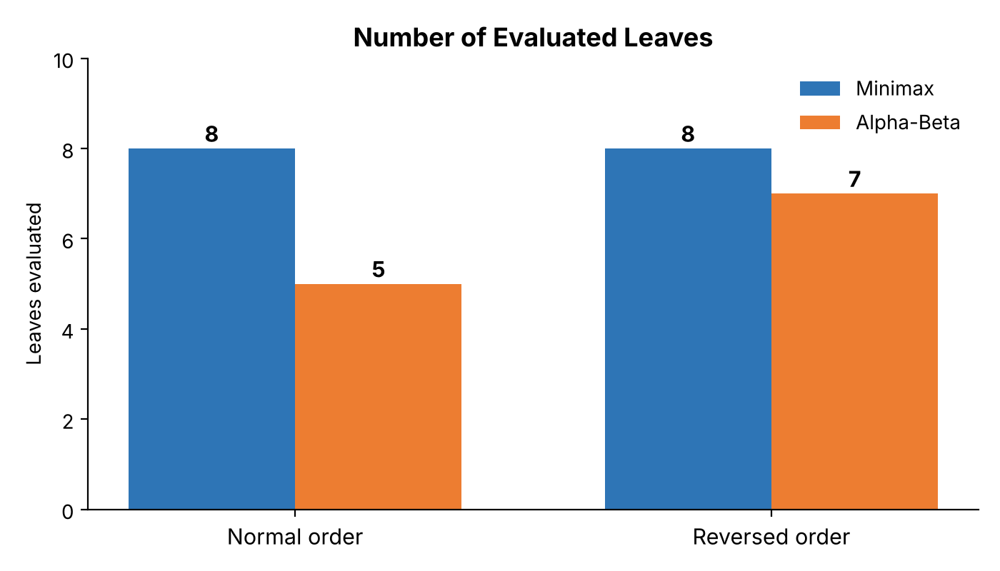
Figure 2: Leaves evaluated by Minimax and Alpha-Beta under normal and reversed branch order.
Test | Minimax value | Alpha-Beta value | Minimax leaves | Alpha-Beta leaves
Normal order | 5 | 5 | 8 | 5
Reversed order | 5 | 5 | 8 | 7
Single-leaf edge case | 42 | 42 | 1 | 1

Interpretation
- Both algorithms return the same optimal value for every test.
- With normal ordering, Alpha-Beta evaluates 3 fewer leaves, a reduction of 37.5%.
- With reversed ordering, Alpha-Beta evaluates 1 fewer leaf, a reduction of 12.5%.
- Better branch ordering can help Alpha-Beta identify unnecessary branches earlier.
- A single-leaf tree has no branches to prune, so both algorithms evaluate one leaf.
The leaf reduction percentage is calculated as:
Reduction = (Minimax leaves − Alpha-Beta leaves) / Minimax leaves × 100
Normal ordering: (8 − 5) / 8 × 100 = 37.5%
Reversed ordering: (8 − 7) / 8 × 100 = 12.5%

11. Edge-Case Testing
The program includes a tree with only one terminal score:
run_test([42])
Expected result:
- Minimax value: 42
- Alpha-Beta value: 42
- Minimax leaves evaluated: 1
- Alpha-Beta leaves evaluated: 1
Explanation: There are no decision nodes or branches to explore. Both algorithms return the only available score. This verifies that the base case works correctly.
Another validation test checks an invalid tree:
run_test([3, 5, 2])
This raises a ValueError because a complete binary tree must contain 2^{n} leaves. The program rejects the invalid input rather than producing an incorrect result.

12. Answers to Lab Tasks

Task 1: Trace the supplied tree using Minimax.
The left MIN subtree returns 5, and the right MIN subtree returns 0. The root MAX node selects the larger value.
Final Minimax value = 5.

Task 2: Add a leaf-evaluation counter.
Both algorithms use counter[0] += 1 in the terminal-node condition. The counter increases whenever a leaf is actually evaluated.

Task 3: Reorder branches and observe pruning.
The program tests normal and reversed branch ordering. The Minimax result stays at 5, while Alpha-Beta evaluates five leaves in normal order and seven in reversed order.
This demonstrates that branch ordering affects efficiency but does not change the optimal Minimax value.

13. Complexity Analysis
Algorithm | Time complexity | Space complexity
Minimax | O(b^d) | O(d)
Alpha-Beta Pruning | Worst case: O(b^d) | O(d)

Here, b is the branching factor and d is the search depth. With favorable move ordering, Alpha-Beta Pruning can achieve approximately O(b^(d/2)) time under ideal conditions.
Minimax explores the full tree. Alpha-Beta Pruning can reduce the number of evaluated nodes, although its worst-case performance is the same as Minimax.

14. Reflection
1. What did you learn today?
I learned how Minimax selects the best move using MAX and MIN decisions. I also learned how Alpha-Beta Pruning reduces unnecessary calculations.
2. How will you apply this in a real AI system?
I can use these algorithms to develop game-playing AI for chess, tic-tac-toe, and other competitive games.
3. What failed or surprised you?
I observed that changing branch order affected the number of evaluated leaves. However, both algorithms returned the same optimal value.
4. What would you do differently next time?
I would improve move ordering by exploring promising moves first. This could help Alpha-Beta Pruning eliminate more unnecessary branches.

15. Responsible Practice
- Use clear and readable code.
- Test the algorithms using different inputs.
- Display the scores and pruning decisions transparently.
- Verify that Alpha-Beta returns the same result as Minimax.
- Report the actual test results without claiming that every branch was pruned.
- Explain the code and acknowledge any reference material used.

16. Viva Questions and Answers
Q1. What is adversarial search?
Adversarial search is a search technique used when two players compete against each other.
Q2. What is Minimax?
Minimax is an algorithm that finds the best move by assuming both players play optimally.
Q3. Why does MAX select the maximum value?
MAX wants to obtain the highest possible score.
Q4. Why does MIN select the minimum value?
MIN tries to reduce MAX's score.
Q5. What is Alpha-Beta Pruning?
It is an optimization of Minimax that skips branches that cannot change the final decision.
Q6. What do alpha and beta represent?
Alpha is the best value MAX can guarantee so far, while beta is the best value MIN can guarantee so far.
Q7. What is the pruning condition?
Pruning occurs when α ≥ β.
Q8. Does Alpha-Beta Pruning change the optimal result?
No. It returns the same Minimax value for the same game tree.
Q9. Why is move ordering important?
Good move ordering can reveal pruning opportunities earlier and reduce the number of evaluated nodes.
Q10. What is a terminal node?
A terminal node is a leaf node containing a final score or utility value.
Q11. What is the result of this experiment?
Both algorithms return 5 for the main game tree. Minimax evaluates eight leaves, while Alpha-Beta evaluates five with normal ordering and seven with reversed ordering.
Q12. Can Alpha-Beta Pruning evaluate more leaves than Minimax?
For the same tree, correct implementation, and evaluation counting method, it cannot evaluate more terminal leaves than Minimax, because it only skips branches.

17. Conclusion
In this lab, Minimax and Alpha-Beta Pruning were implemented and tested using Python. Both algorithms produced the same optimal value of 5 for the main game tree. Minimax evaluated all eight terminal leaves, while Alpha-Beta Pruning evaluated fewer leaves depending on branch ordering. The edge-case test also confirmed that both algorithms work correctly when the tree contains only one terminal node.
The experiment demonstrates that Alpha-Beta Pruning improves search efficiency while preserving the optimal Minimax decision.

